**Lab 5**

**Task 1.A**

In this task, we need to implement a simple kernel module by running the makefile to make and compile the hello.c file.

The steps were to run the ‘make’ command.

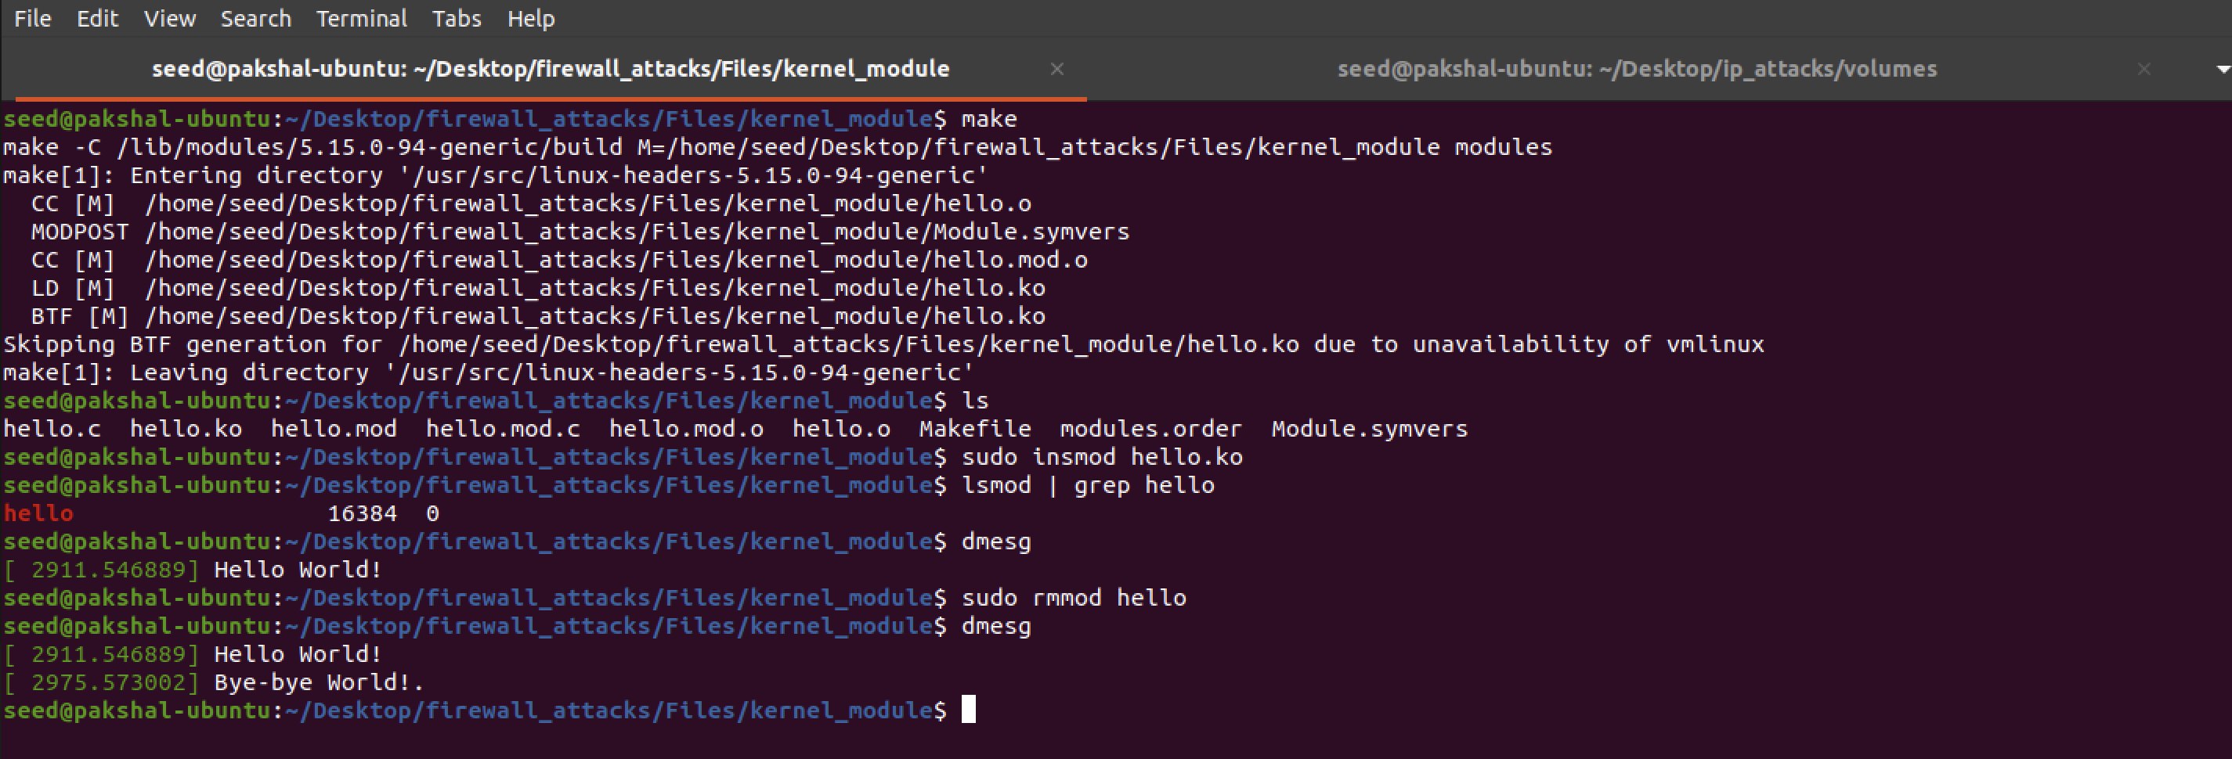

We can see in the above screenshot soon after I loaded the kernel module I ran dmesg and it had printed “Hello World!”.

After removing the module was uninstalled it printed the message “Bye-bye World!”.

Before running dmesg commands I had cleared the messages using sudo dmesg -c

**Task 1.B: Implement a Simple Firewall Using Net filter**

In this task, we will write our packet filtering program as an LKM, and then insert in into the packet processing path inside the kernel

Net filter is designed to facilitate the manipulation of packets by authorized users. It achieves this goal by implementing a number of hooks in the Linux kernel.

Here we will use LKM and Net filter to implement a packet filtering module which will fetch the firewall policies from a data structure and use the policies to decide whether packets should be blocked or not.

Before running any code, the dig command works because there is no firewall running.

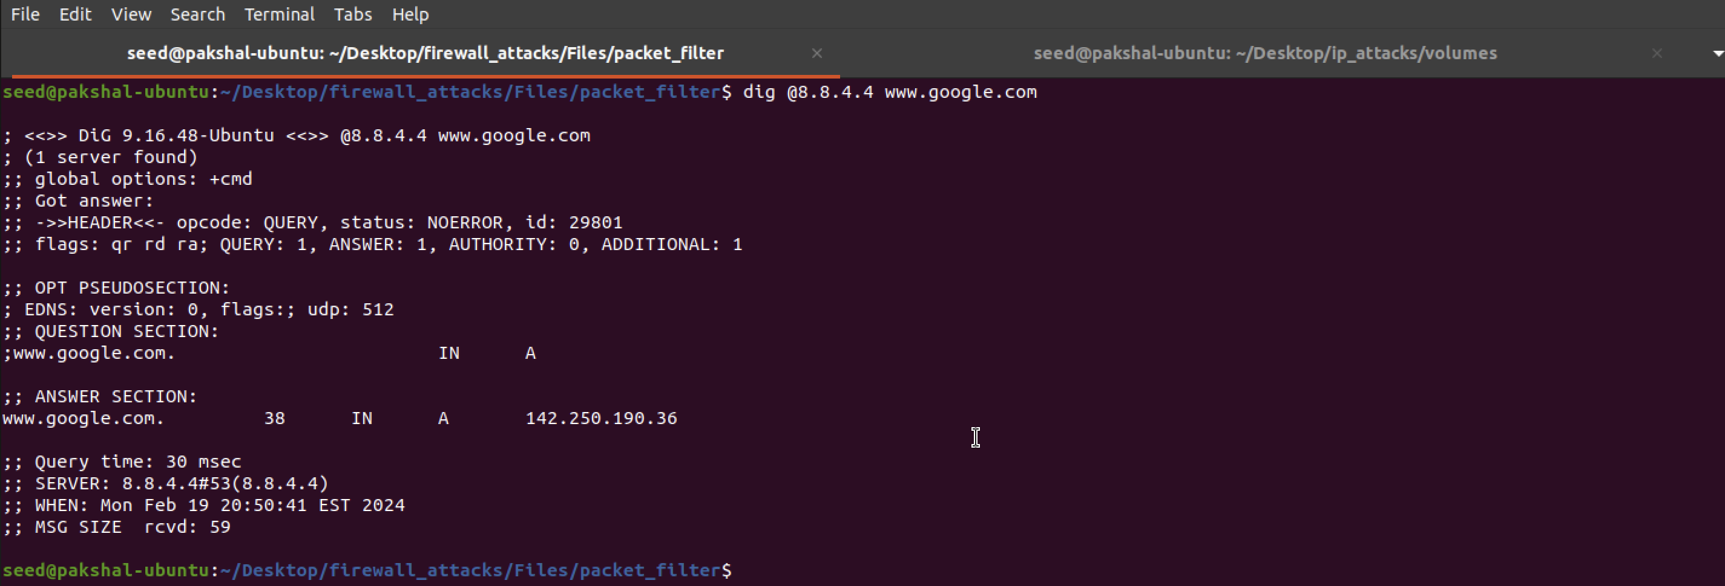

Now we run the running the make command and then installing the seedFilter module as shown below.

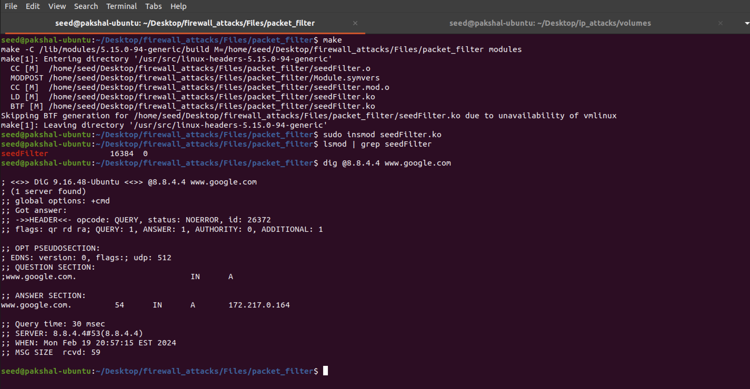

Here we can see that the request was blocked by the firewall showing that LKM is working.

**Task 1.B.2**

Here we need to hook the printInfo function to all the netfilter hooks. After modifying the code, it looks like below.

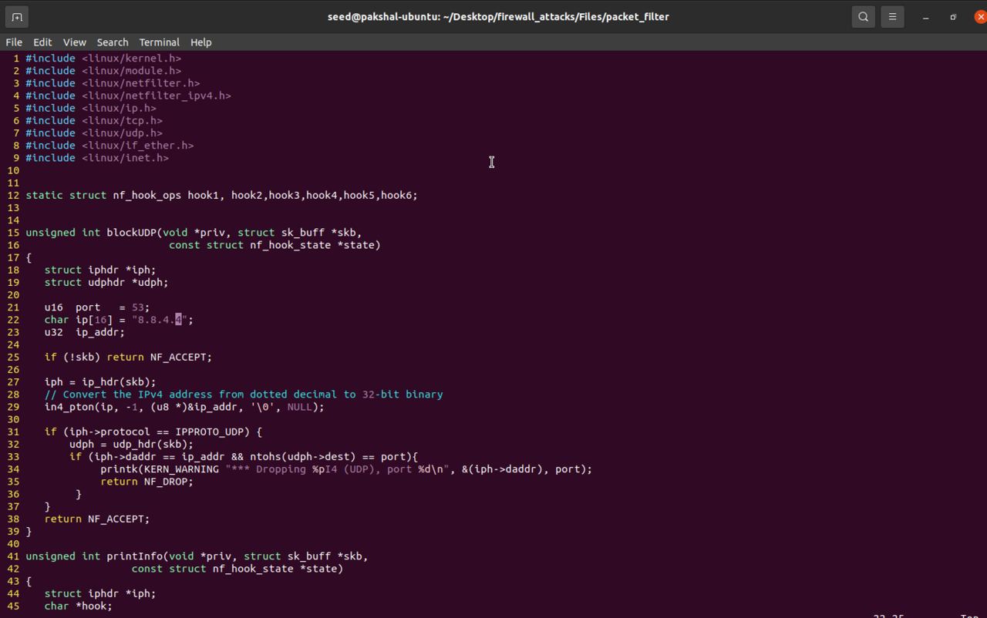

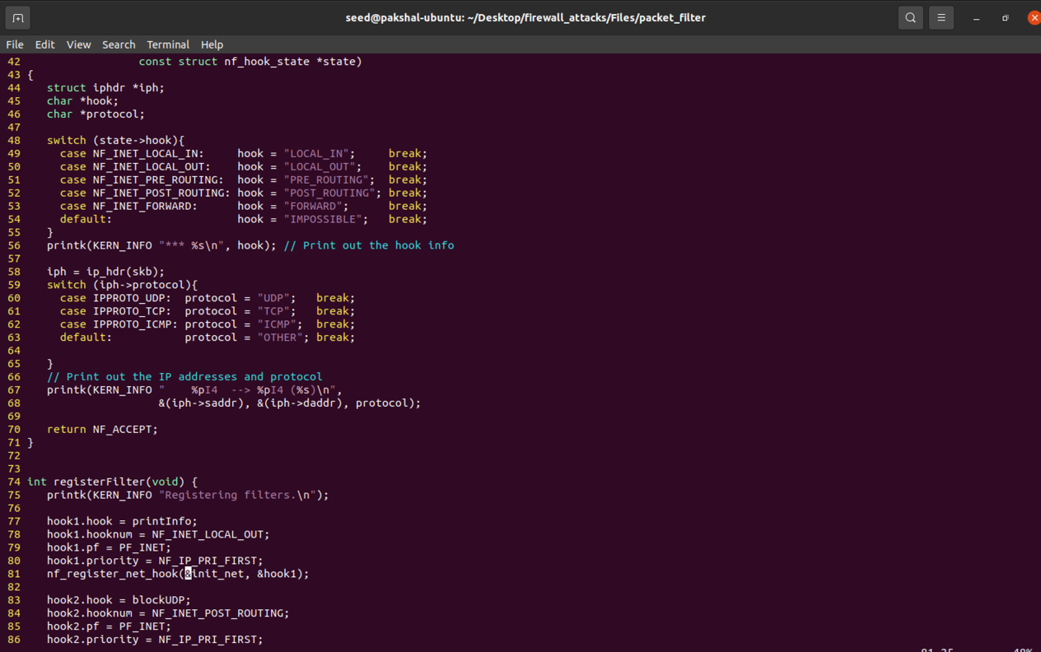

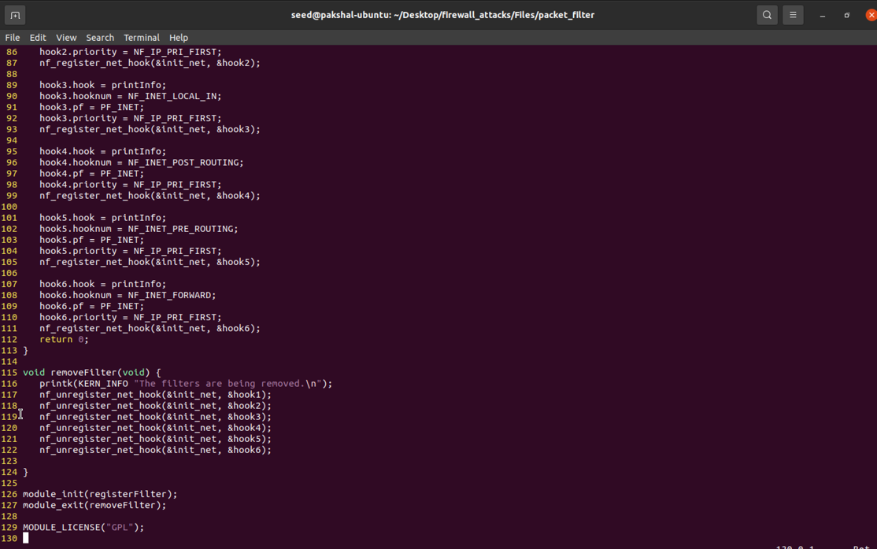

We run make command and then install the module and then we run the dig command and then check dmesg to see the output printed.

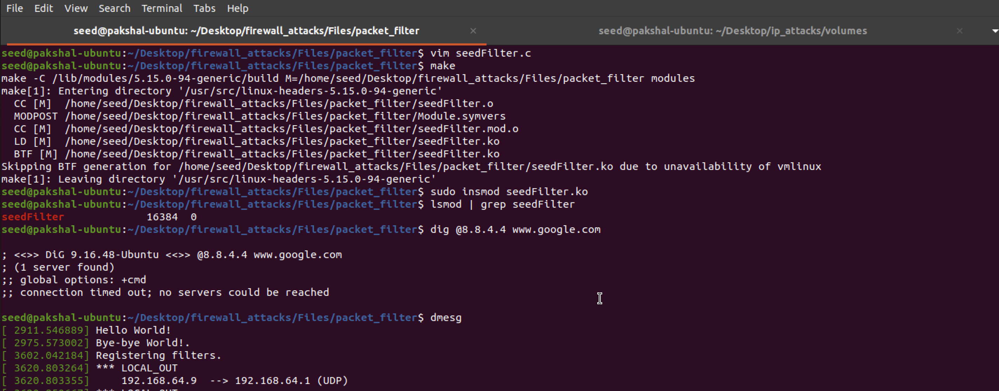

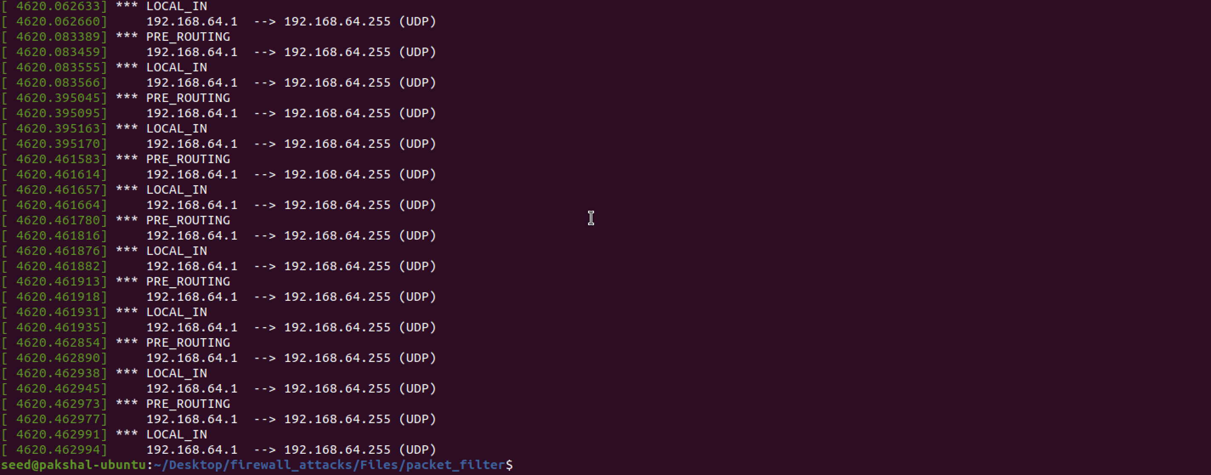

We can see that the request is blocked by the firewall. Thus the LKM is working correctly.

**Task 1.B.3**

In this task we need to implement 2 hooks. One hook to block ping requests and other to block telnet requests.

The modified code is shown below.

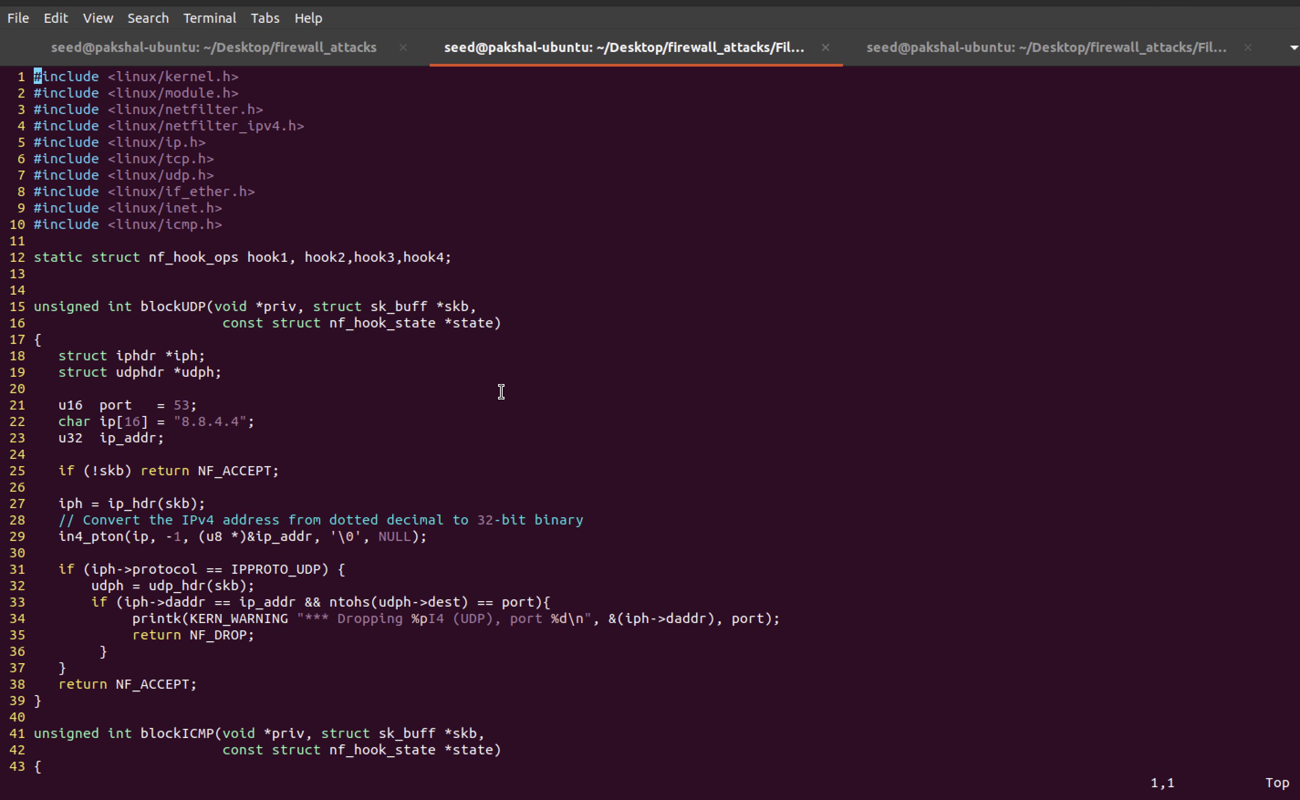

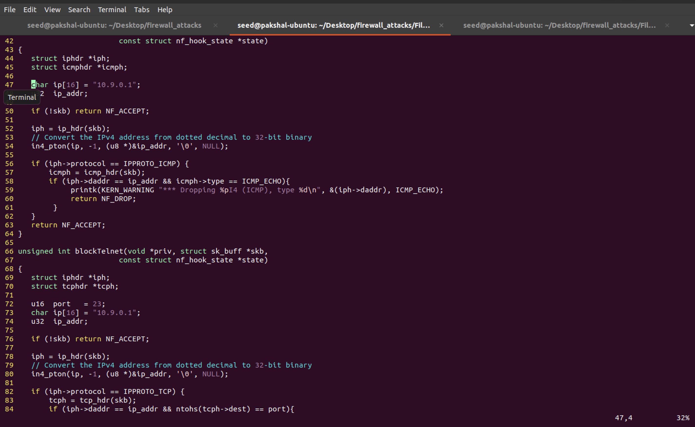

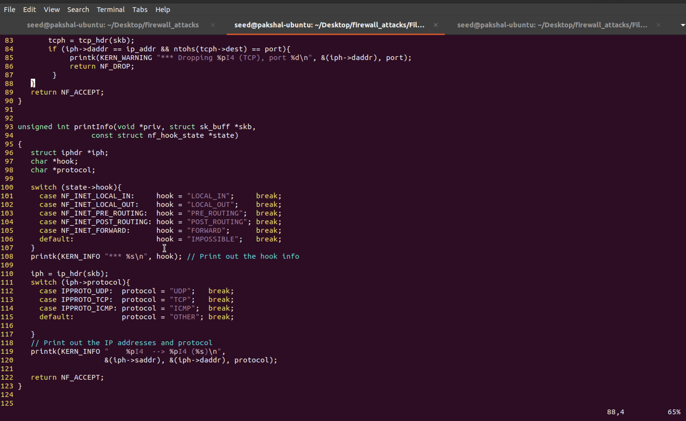

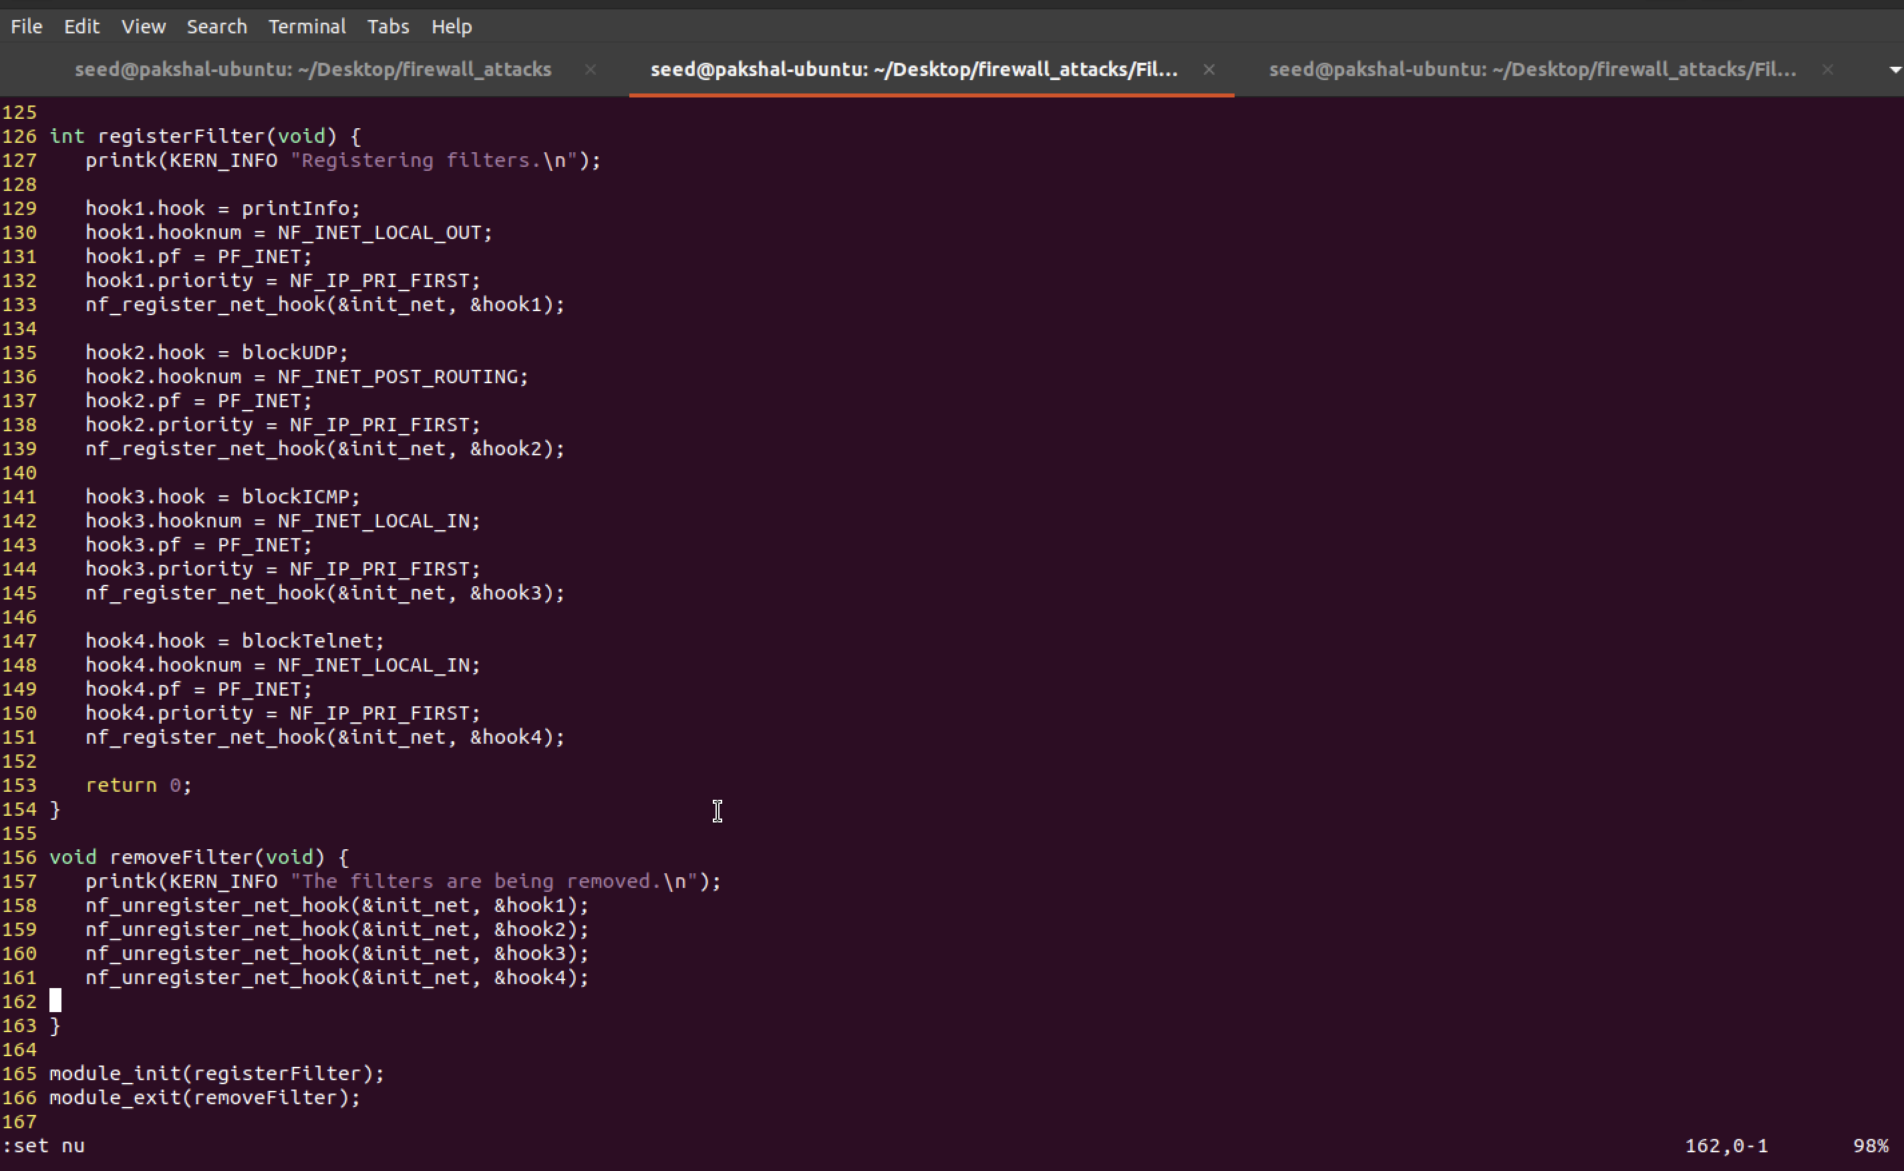



We run make and then install the module

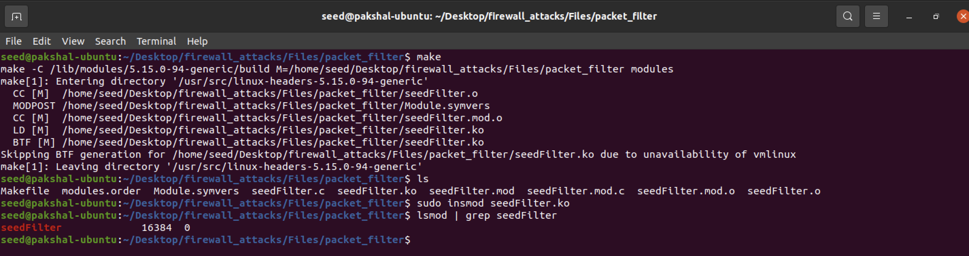

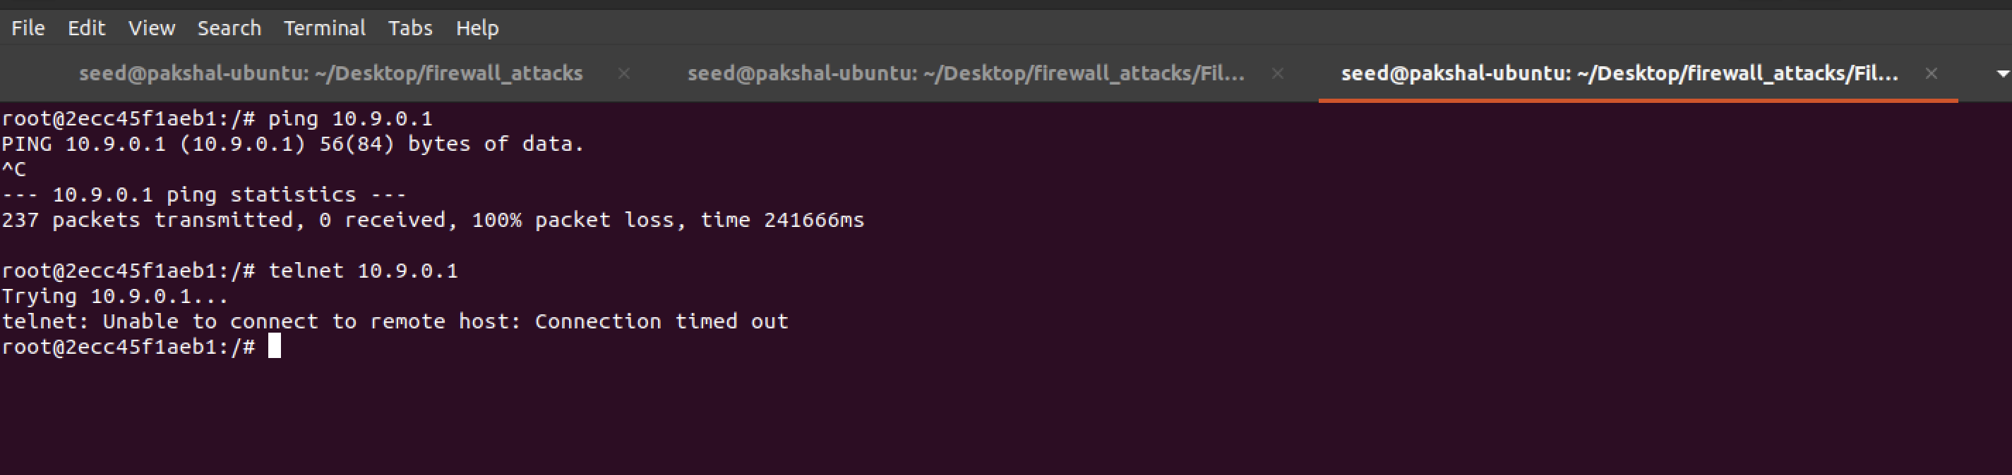

On running a ping command, we can see that it fails – which means that the blockICMP() function is working. On doing telnet we can see that it is blocked too.

**Task 2**

In this task we use iptables to set up stateless firewall rules. Here is how the filter table looks like without any rules added

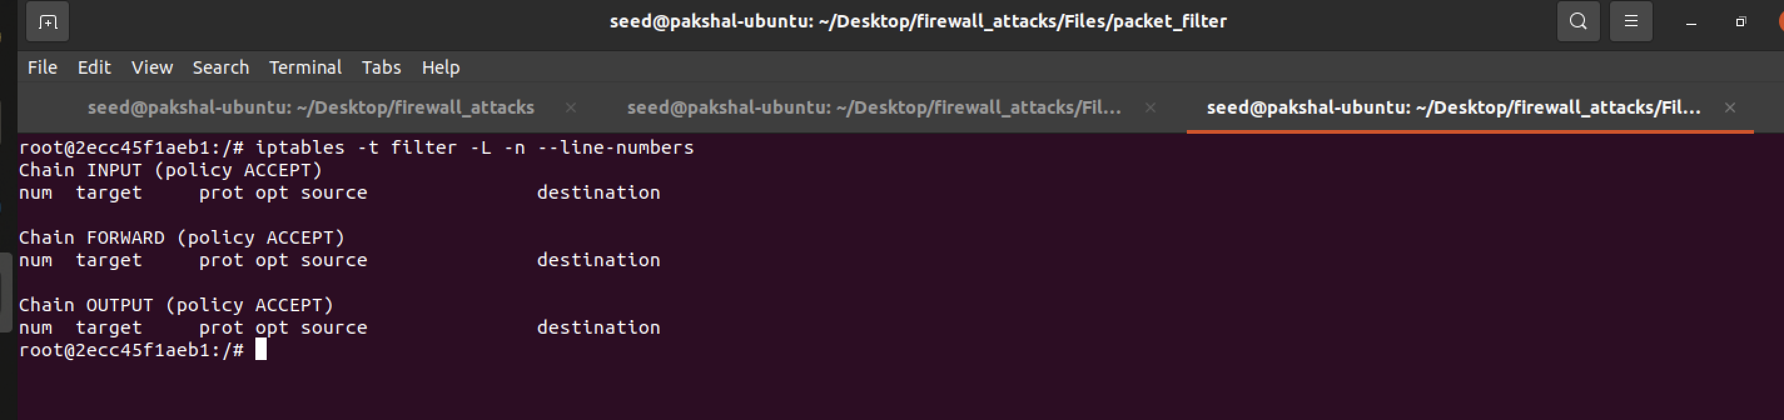

**Task 2.A**

In this sub-task, we add rules to the filer table to be able to accept ICMP replies and requests. The INPUT chain rule allows ICMP echo requests to pass through and the OUTPUT chain rule allows echo replies to go through.

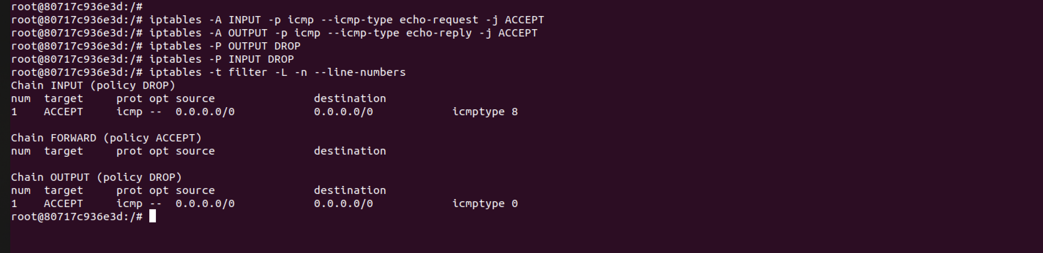

From Host A and try to ping the router and it works.

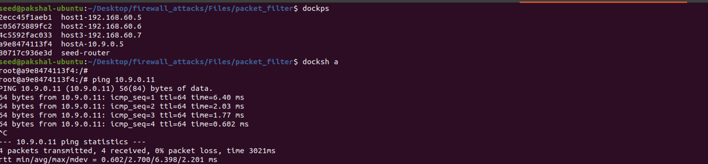

When we try telnet to the router, it is blocked by the firewall because in the rules all other packets should be blocked as a result the packets were dropped.



We clear out the table using the following commands

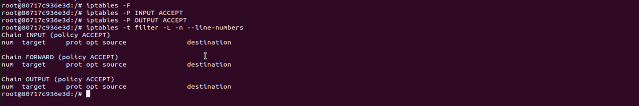

**Task 2.B**

We add the following rules to the filter table to protect the internal network 192.168.60.0/24 using firewall rules.

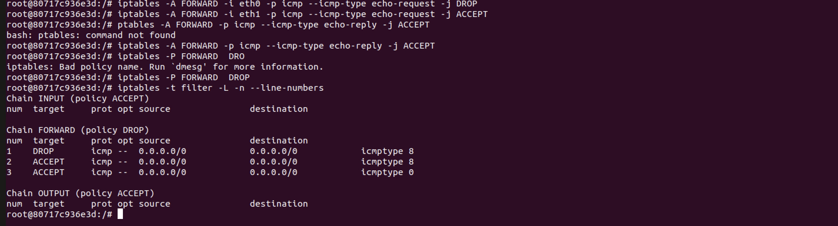

We accept only ICMP echo requests to the internal network with their replies and drop all the other packets. We now try pinging the network from an outside host i.e. host A, and the ping fails

External host cannot ping internal host.

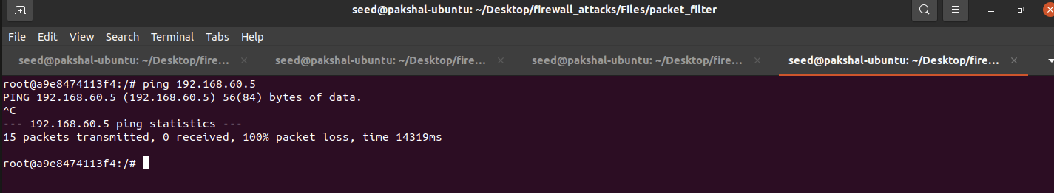

Internal hosts can ping external hosts

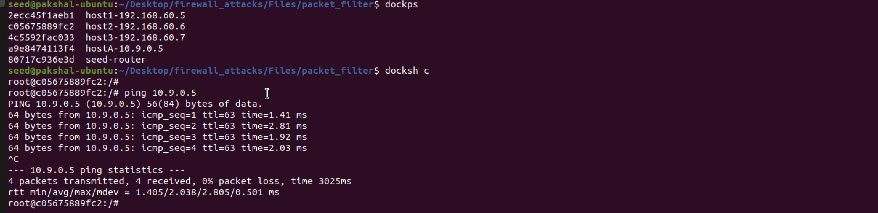

When we ping the router it works because nothing was changed with respect to the router.

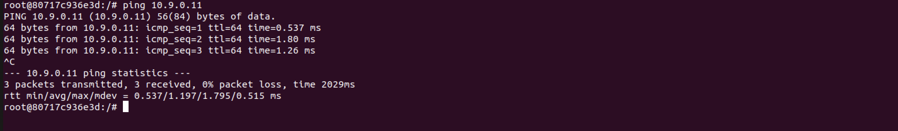

**Task 2.C**

The task is toprotect the TCP servers inside the internal network by allowing TCP packets only to 192.168.60.5 and dropping all other packets.

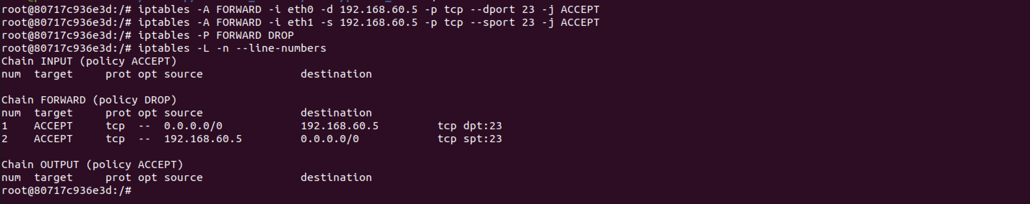

**Here host access is allowed only on 192.168.60.5 from externally, a telnet from an external host to this should also work as we allow tcp protocol in the rules.**

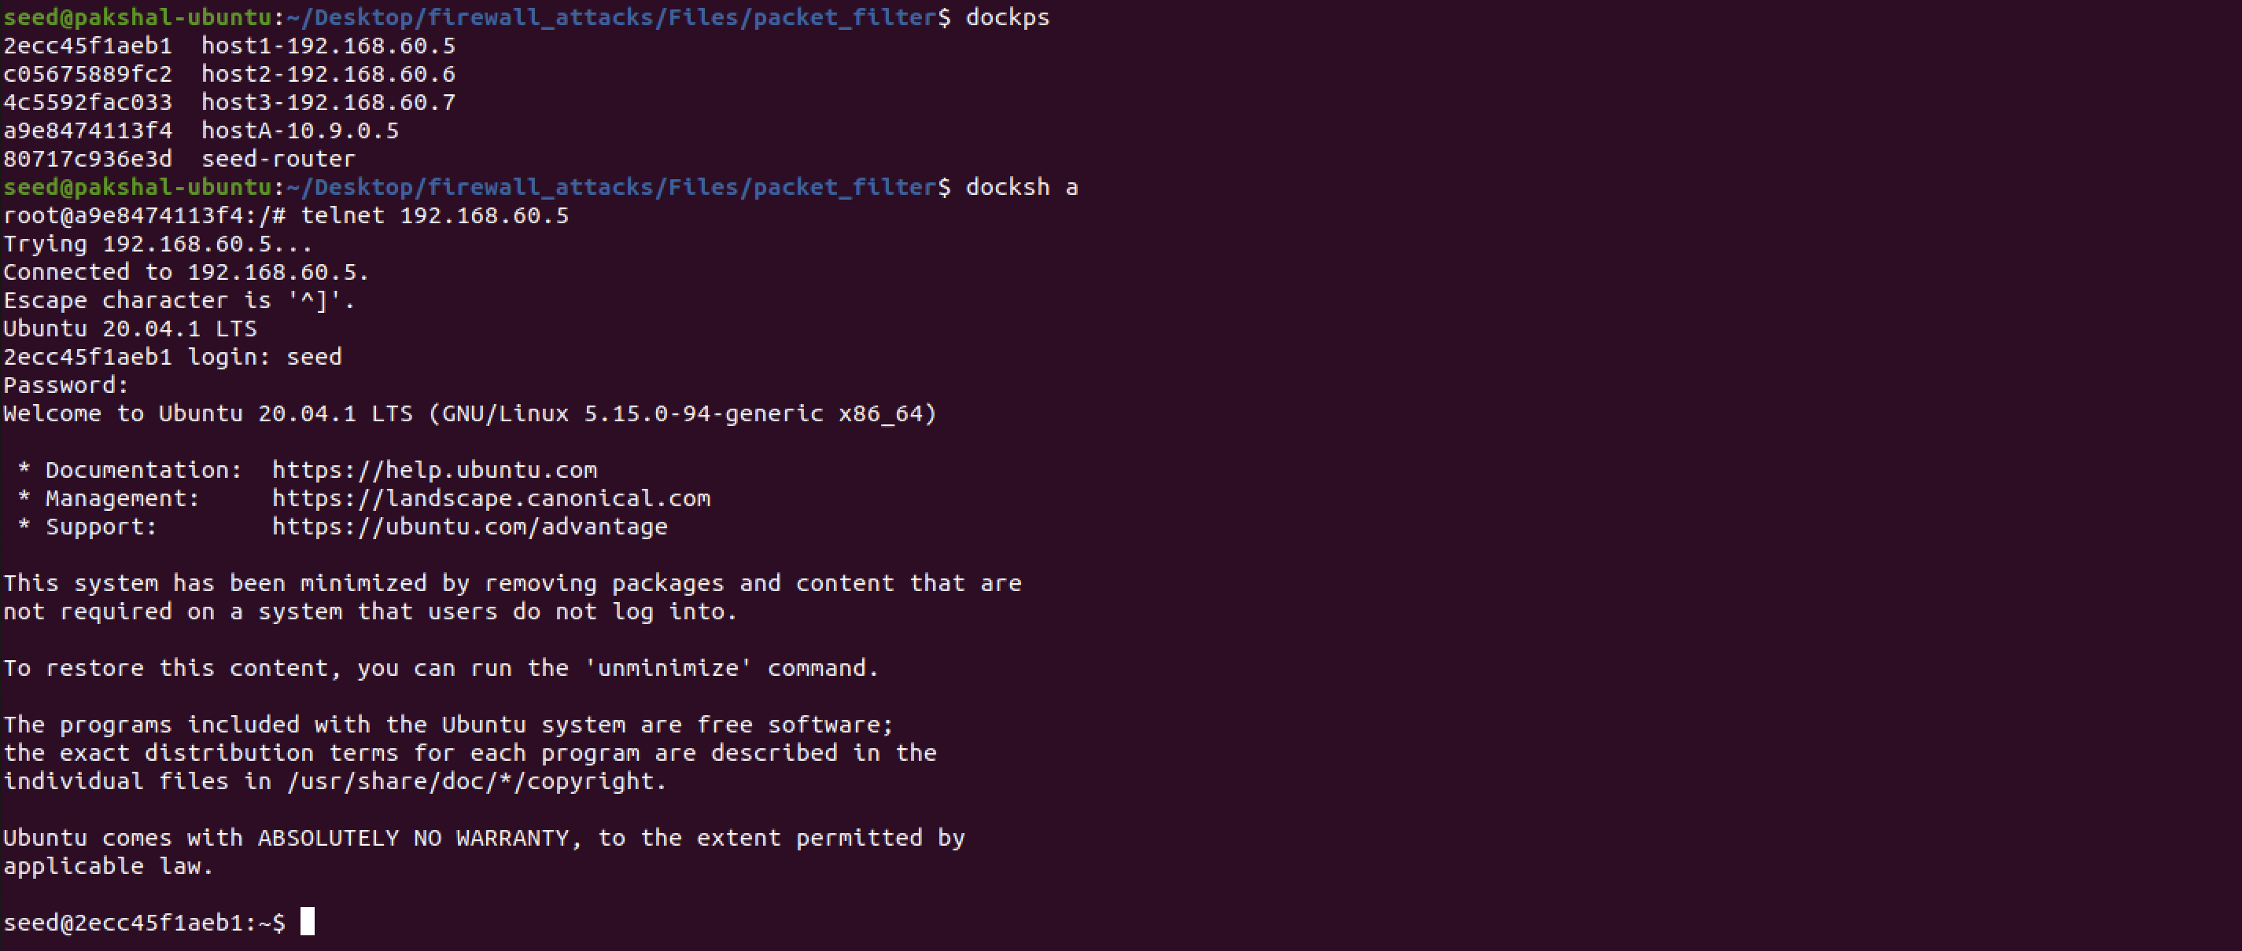

**telnet from external host to 191.168.60.5**

We are able to access 192.168.60.5 from external host 10.9.0.5

When we try to tenet to 192.168.60.6 it does not work because external host can access the telnet server on 192.168.60.5, not the other internal hosts. Outside hosts cannot access any other internal servers.

Accessing internal server from internal host.

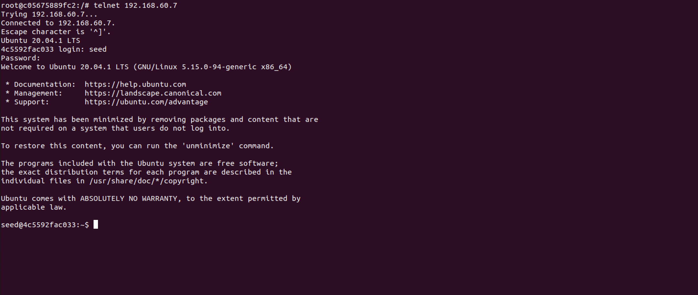

Telnet from 192.168.60.6 to 192.168.60.7

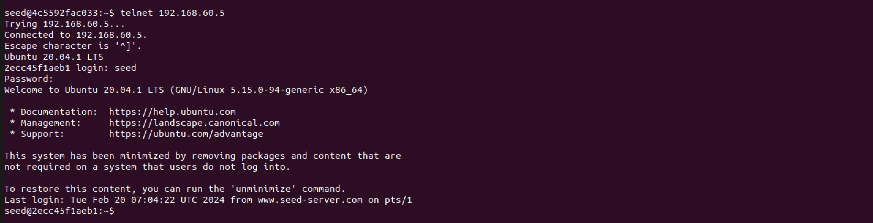

Telnet from 192.168.60.7 to 192.168.60.5

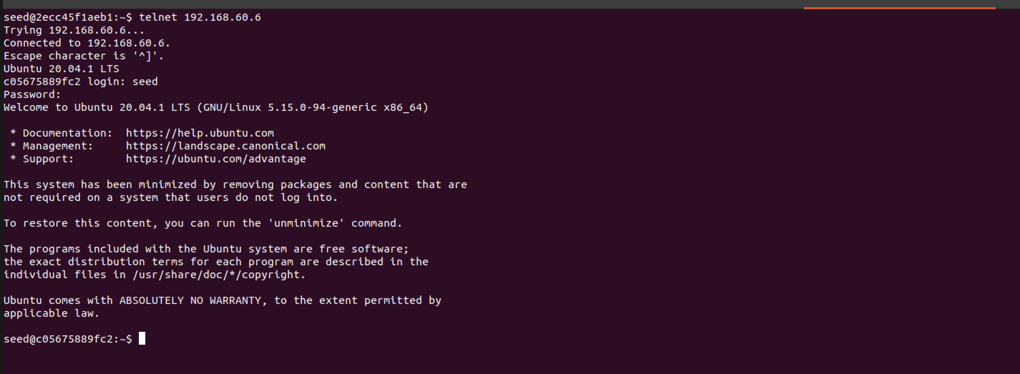

Telnet from 192.168.60.5 to 192.168.60.6

All internal hosts can access all other internal hosts as shown above. But If we try telnet to external server this fails and all internal servers are protected.



**Task 3.A**

In this task we try to understand conntrack

we will check the connection tracking information on the router container as shown below

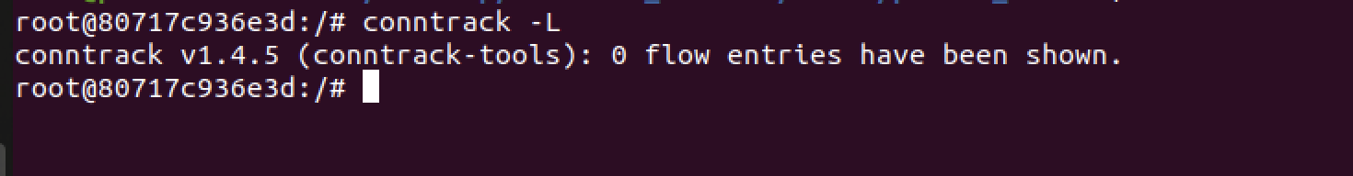

* ICMP experiment: Here we run the ping 192.168.60.5 command on external host and check the connection tracking information on the router.

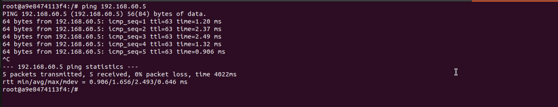

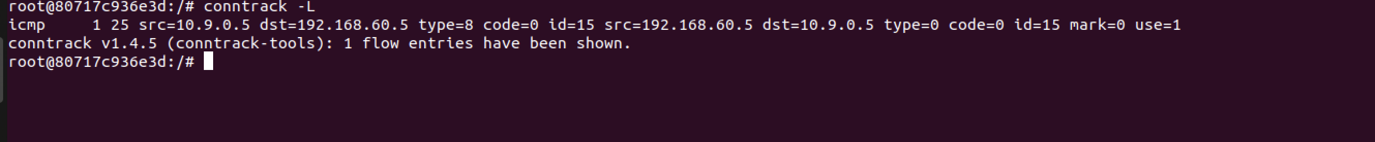

Now we see how long the connection is kept.

Including the amount of time it took me to go to the router instance and type the command, this information with the flow entry is kept for 30-35 seconds or so.

* **UDP Experiment:** We use netcat to send a UDP packet





Including the amount of time it took me to go to the router instance and type the command, this information with the flow entry is kept for 30-35 seconds or so.

* **TCP Experiment:** On 192.168.60.5, we start a netcat TCP server and send out TCP packets on 10.9.0.5





We check conntrack to track how long the connection is kept

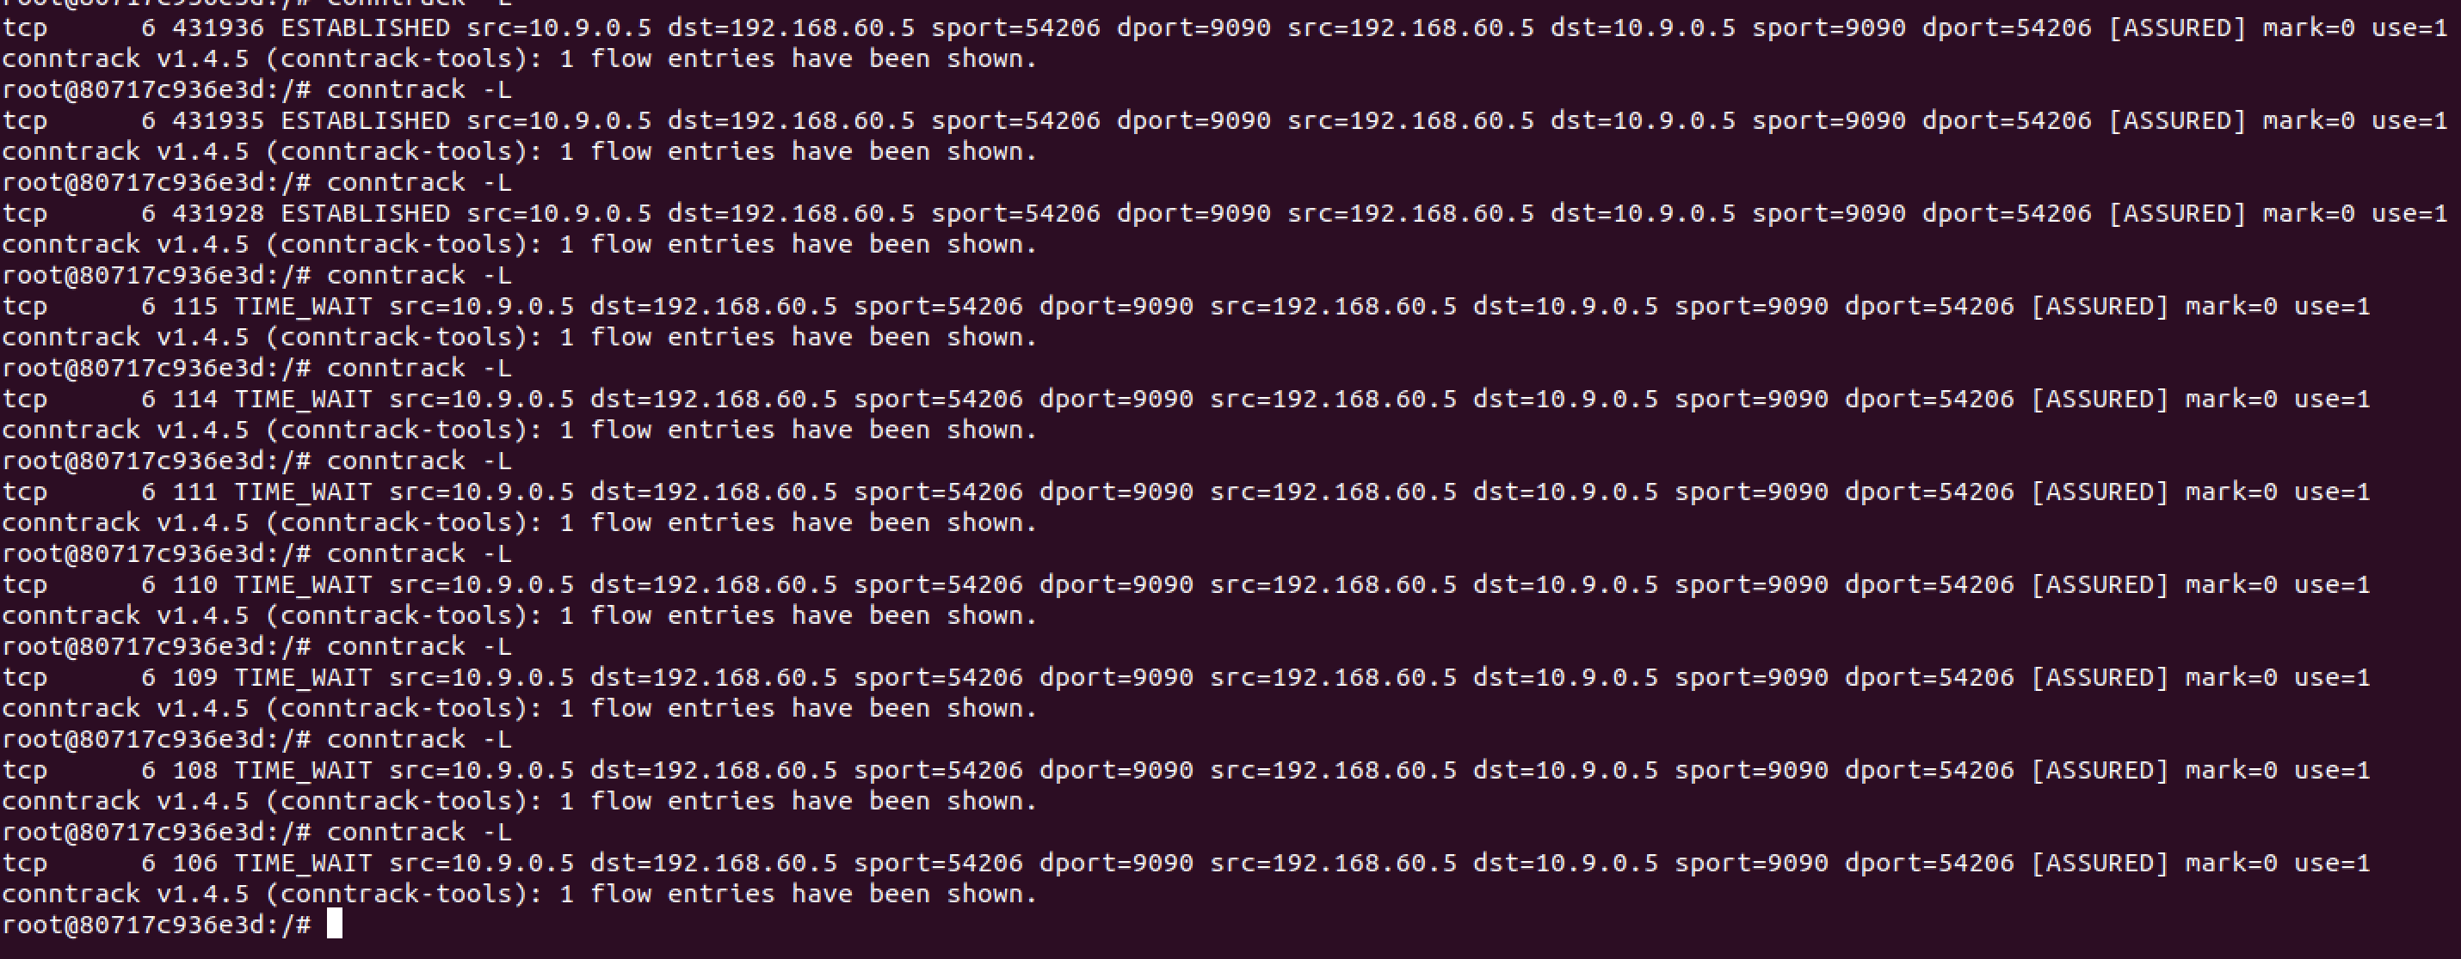

When the connection is running, the timeout value is very large. When connection is stopped, this timeout value goes down. The flow entry is kept for 120 seconds or so.

**Task 3.B**

In this sub-task, we need to set up firewalls based on connection, using the conntrack module in iptables. We need to allow TCP packets belonging to an existing connection (192.168.60.5) to pass through, accept incoming SYN packets, allow internal hosts to visit any external server and set the default policy on FORWARD to drop everything.

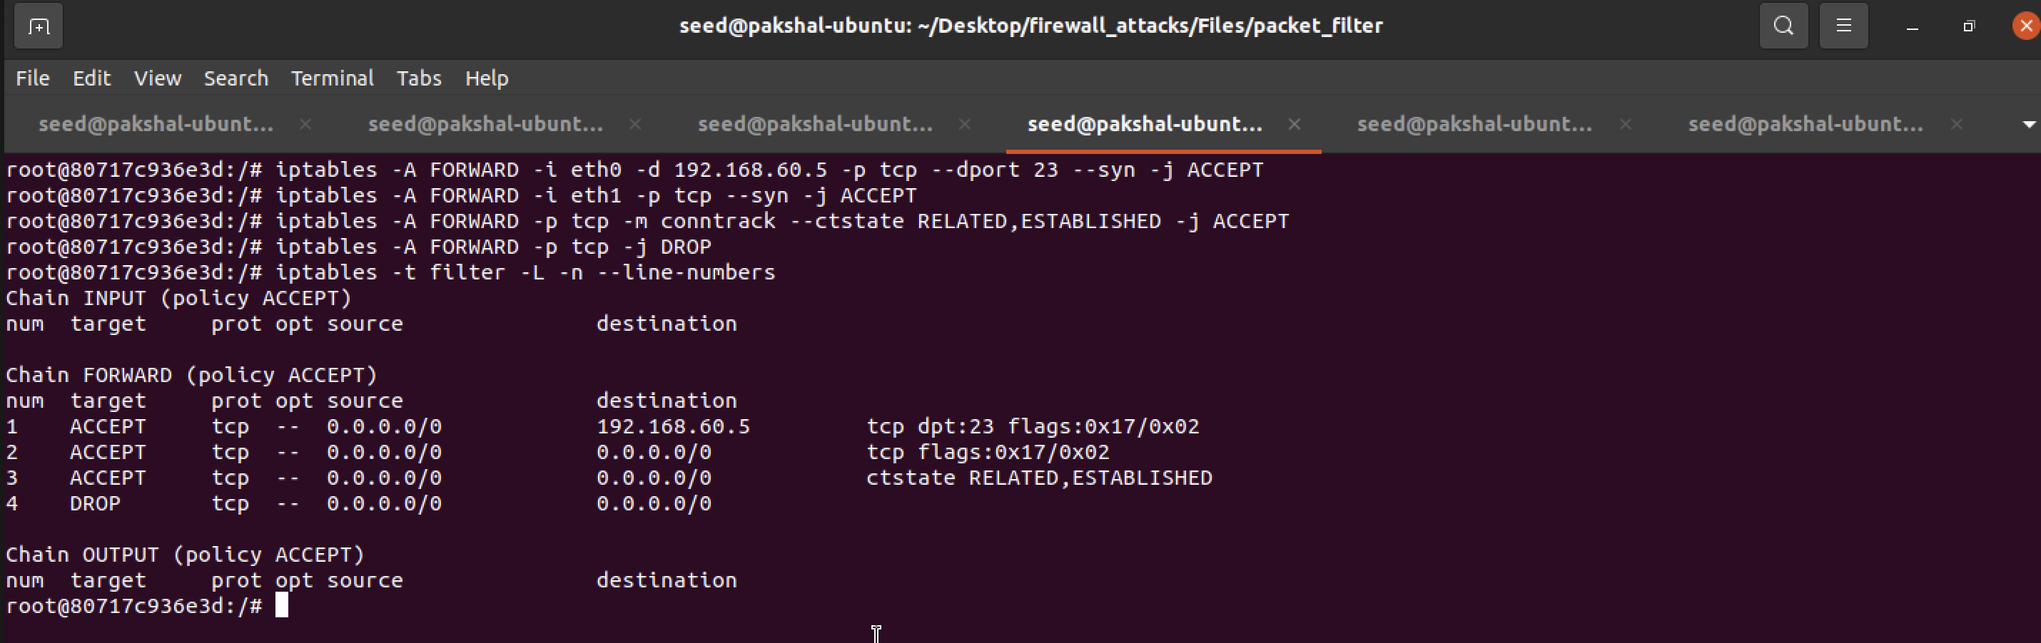

On the external host A, we try to telnet into 192.168.60.6 and this does not works wheras when we try to telnet into 192.168.60.5 it works because of the firewall rules setup that would block any TCP packets that do not belong 192.168.60.5

The ones belonging to 192.168.60.5 are accepted.

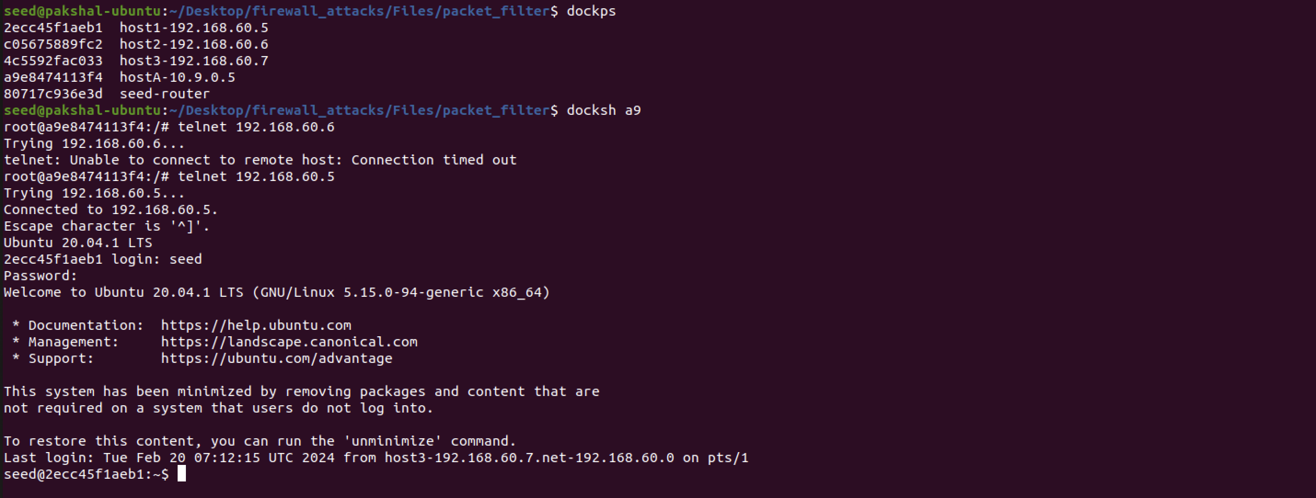

In order to show that internal host can we visit any external server, we try to. telnet to external host from internal hosts.

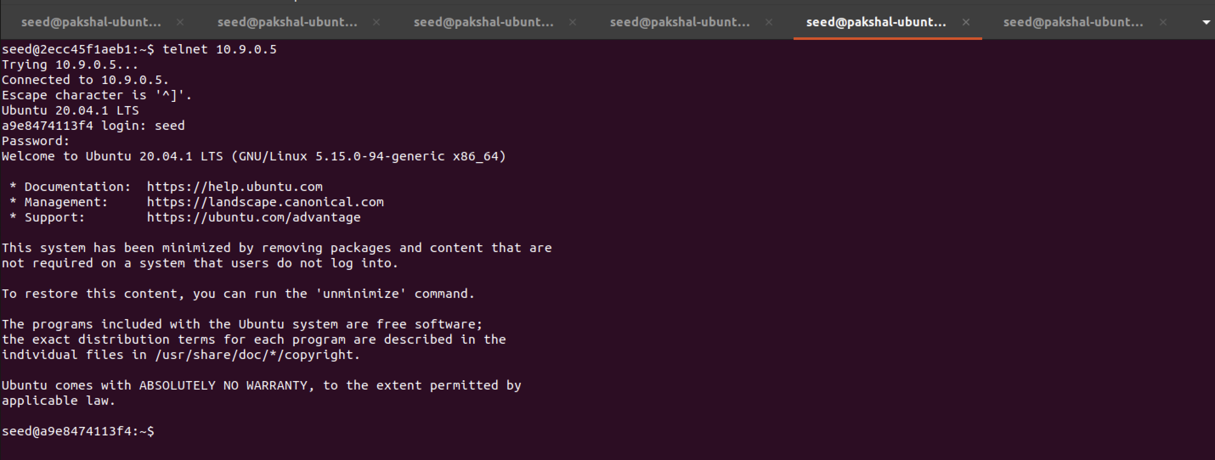

Can this be done without connection tracking?

It would be difficult to determine which packets belong to existing connection whether they are from external to internal or from internal one to external.

The rules we added allows packets from internal host to go to external but not vice versa. We could do this by using the SYN packet for the external server and would not need any extra resources too.

The advantage of conntrack is that it allows us to track connections and maintain stateful firewalls but its disadvantage is that it uses extra resources to do this.

**Task 4**

In addition to blocking packets, we can also limit the number of packets that can pass through the firewall. This can be done using the limit module of iptables.

In this task, we will use this module to limit how many packets from 10.9.0.5 are allowed to get into the internal network.

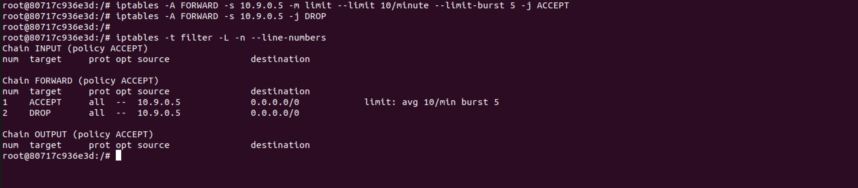

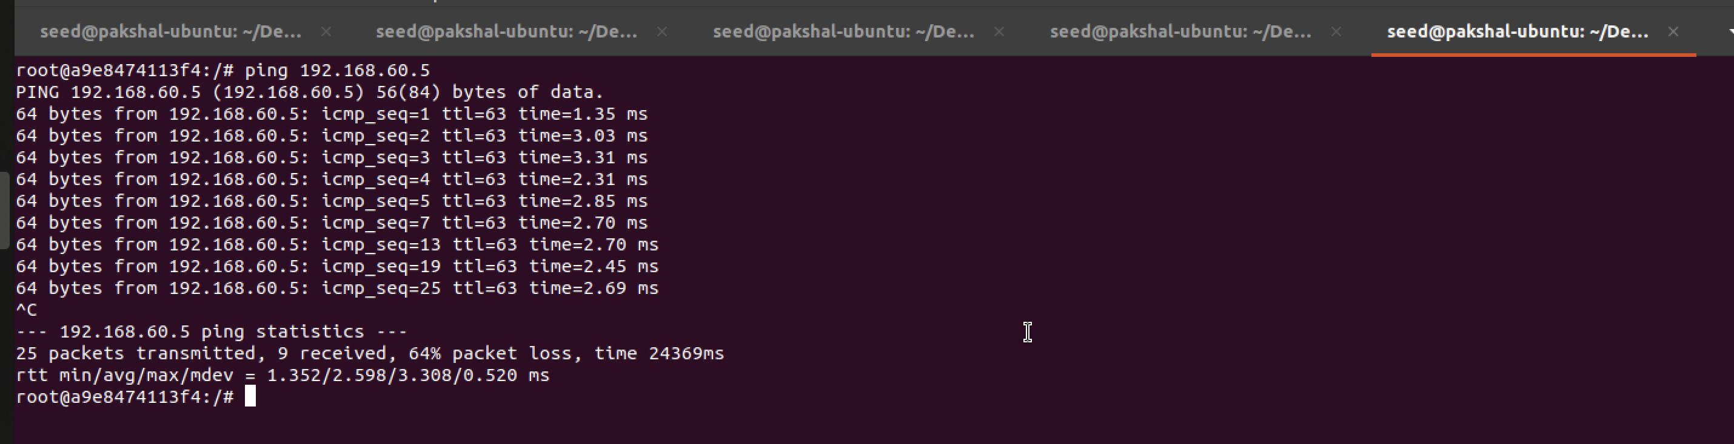

Now we, run only the first rule.

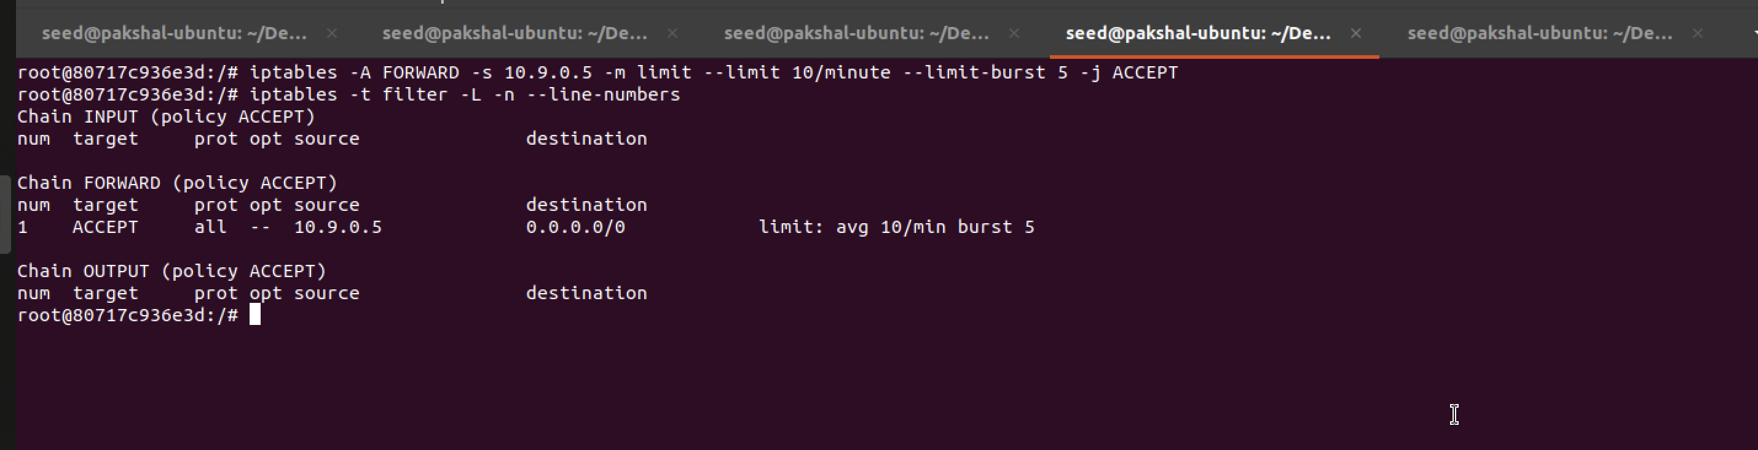

We ping 192.168.60.5 from 10.9.0.5

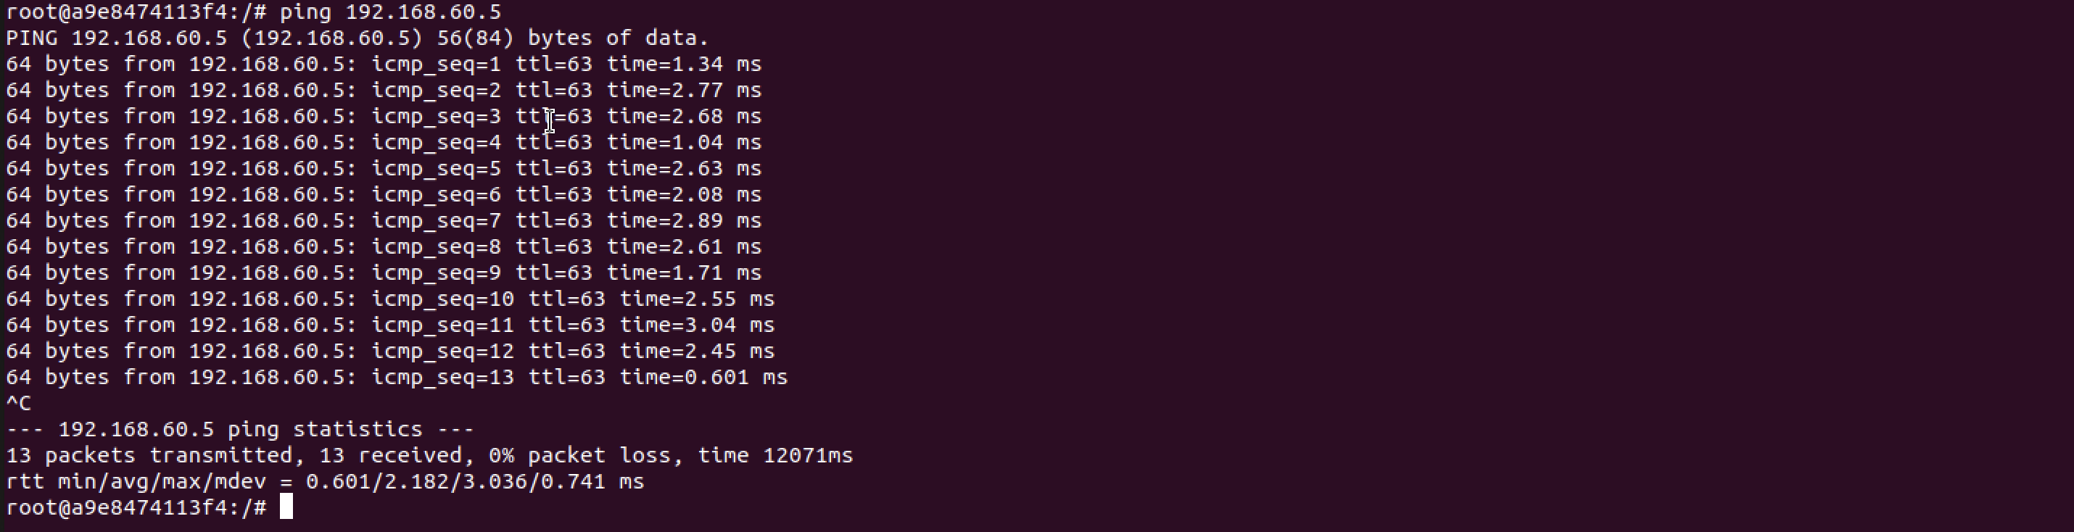

The FORWARD policy by default accepts the packets that’s why without the second rule all packets are accepted. Whereas when we have second rule, every packet for every 6 seconds is accepted and other packets in between are dropped after the burst of 5 is reached.

**Task 5**

In this task, we will use iptables to load balance three UDP servers running in the internal network.

**Using the nth mode (round-robin)**

We add the following rules. In the first rule out of 3 packets the 0th packet is sent to the 192.168.60.5 destination. Now there would be 2 packets, in that we are sending the packet 0 to 192.168.60.6 destination. Now there is only 1 packet left so by default we are sending it to 192.168.60.7 destination.

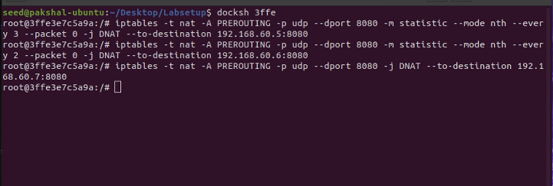

We will start the server on each of the hosts: 192.168.60.5, 192.168.60.6, and 192.168.60.7

-k option indicates that the server can receive UDP datagrams from multiple hosts.

We now send 7 UDP packets from 10.9.0.5

We can see that equal number of packets have been sent to each. In the next round the 7th packet was sent.

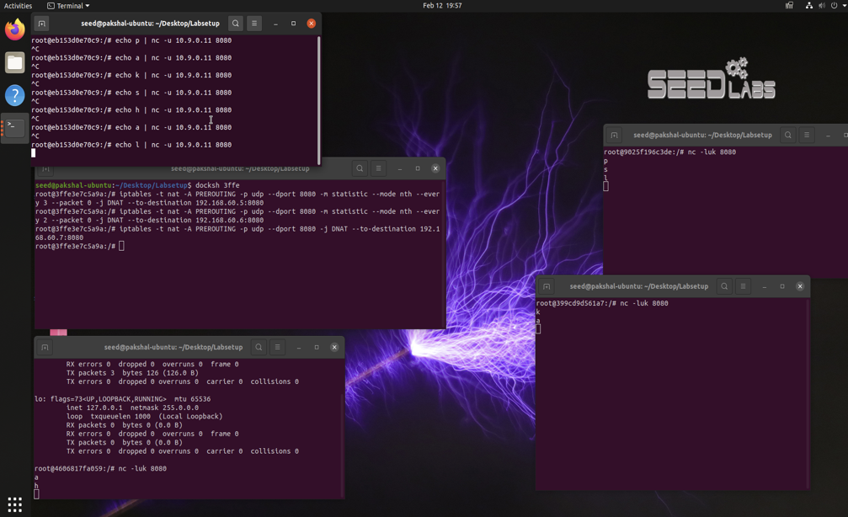

**Using the random mode**

Using this mode, we set up the following rules with a probability of 0.3 to allow 30% of the packets to 192.168.60.5 ,30% of the remaining to be sent to 192.168.60.6 and the others to 192.168.60.7

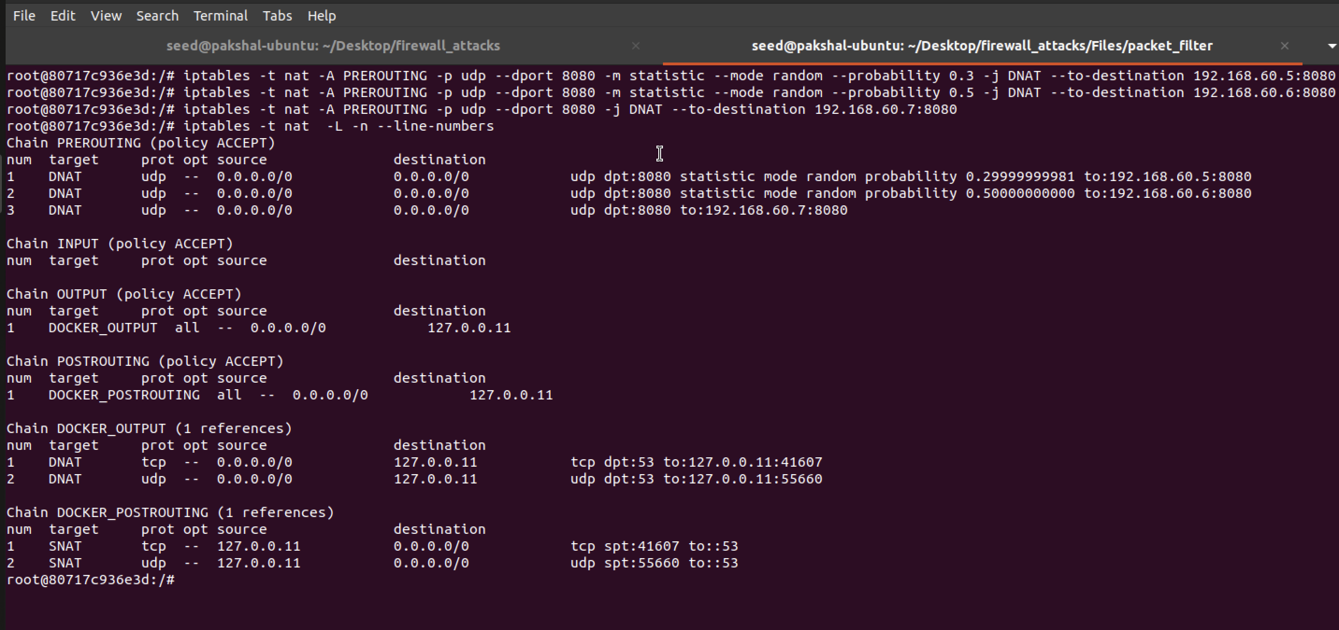

We set up UDP servers on all the 3 internal hosts with the nc -luk 8080 command. Then we send 10 UDP packets from 10.9.0.5

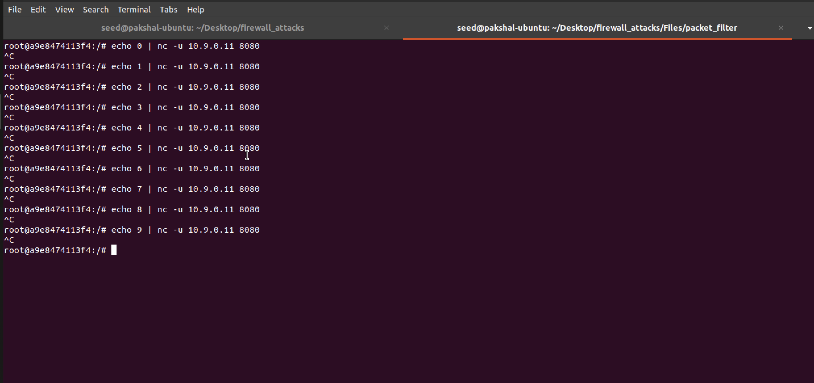

Packets are sent in a random way based on the probability given.

